BURNS MB 319 AWD BUILD SPEC 2021

ROOF RACK DESIGN SPEC V1

Side ladder driver side (next to the side mounted Maxx Trax in same position as side window on passenger side) SO Maxx trax not covered

The roof has a front/rear window vent and a vent for the wet room with a solar panel mounted on the roof rack floor. The first picture below is similar to the roof layout. With this roof rack the vents sit about 3-5cms above the rack floor.

Will need to move solar panel to front section ahead of front vent?

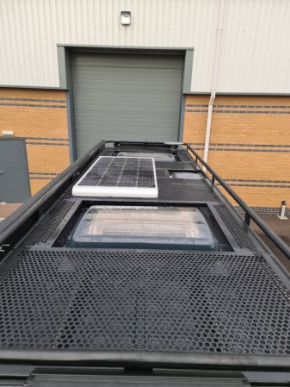

I want to have the rack floor just above the vents, so they can be covered as in the second picture. So the height of rook rack floor needs to be elevated to achieve this.

C:\Users\The Van Traveller\Pictures\VAN THINGS TO CONSIDER (1).png

Either lift in/out panels secured with latches or perhaps preferably even hinged so they don't have to be taken down . The main purpose of the covered sections is so I can safely walk over the roof space particularly when putting the kayaks up there but also so the space can be used as a viewing deck and rest area.

The drawing below illustrates how the fenestrated floor plates would rest inside the space above the vents supported with a plate welded to the perimeter with sufficient overlap to be well supported. Then secured with a suitable catch lock device like the one below. The smaller and lower profile the better

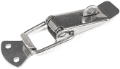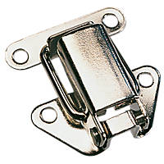

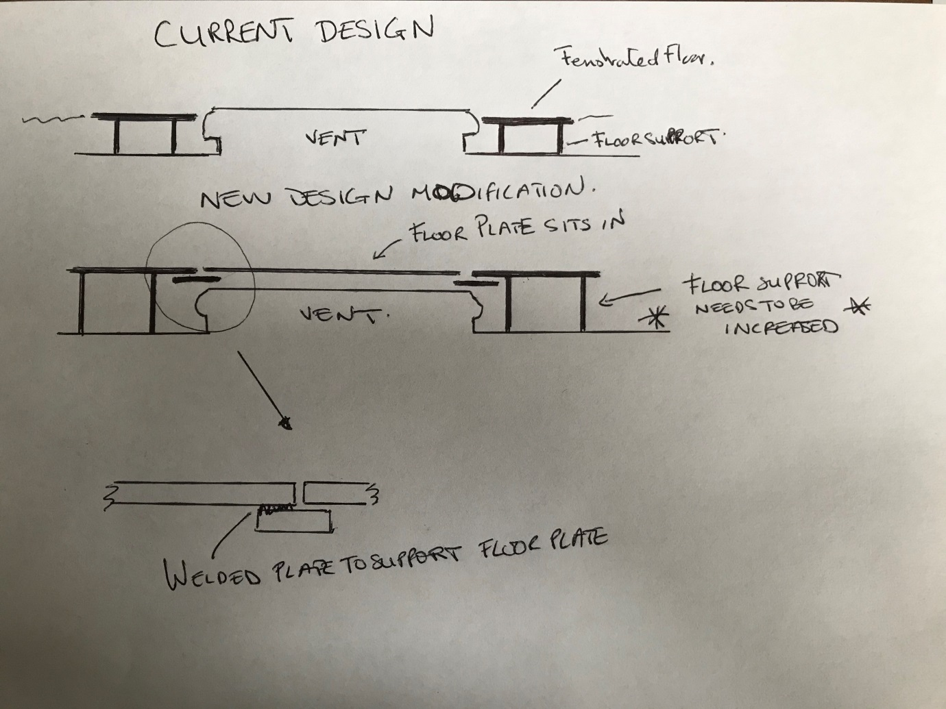

Currently, the solar panel is mounted on top as in this picture. I would prefer it to be 'sunk in' cradled in some way so that it too can be covered. I like the fenestrated floor, and would want this throughout the floor space.

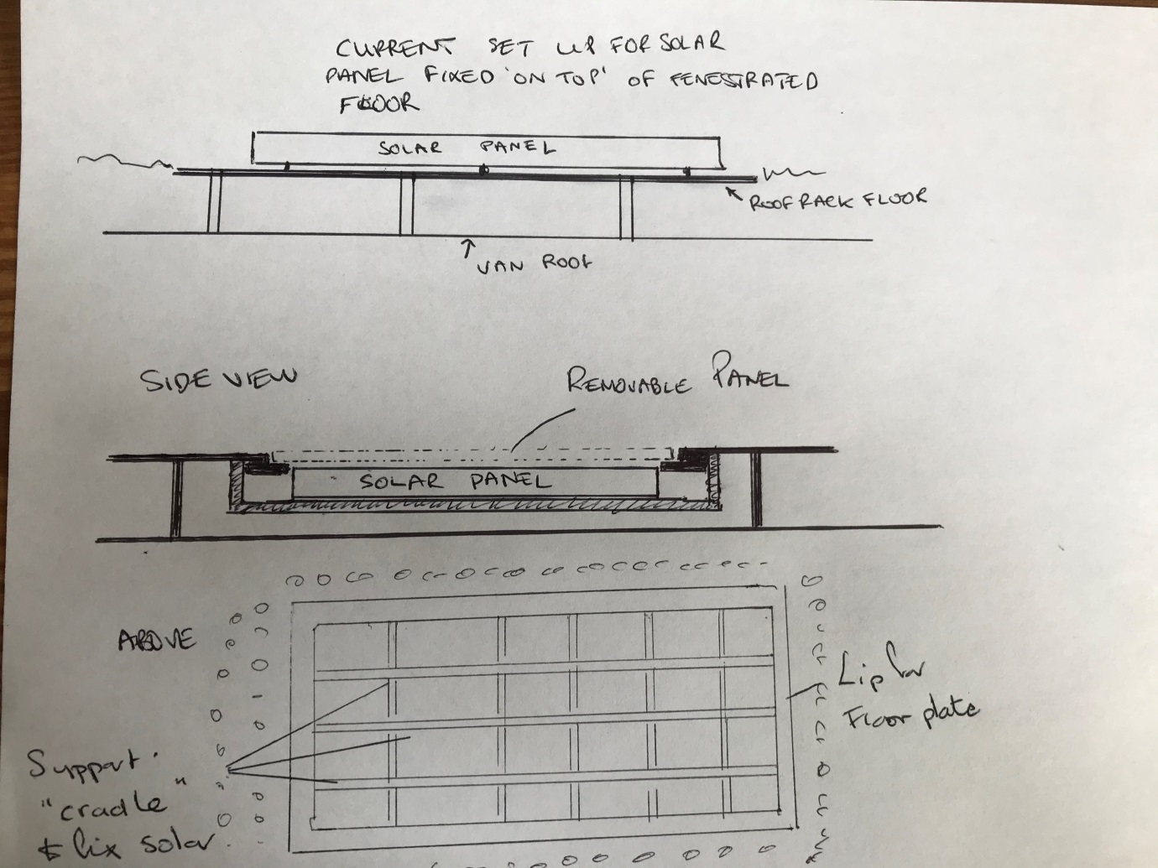

**Mounting Kayaks x2**

The perimeter bar at the rear would need to drop down in on the passenger side, to house a roller bar to allow a kayak to be pulled up. This will have to be to one side because of the rear view camera housing. Below is a drawing and are images of existing products for ladders to be pulled on to roof racks for illustration. They are generally attachments to the rear roof bar. I would ideally want a roller to be incorporated into the perimeter bar to one side to avoid rear camera housing. But whatever works if a separate attachment is necessary so be it.

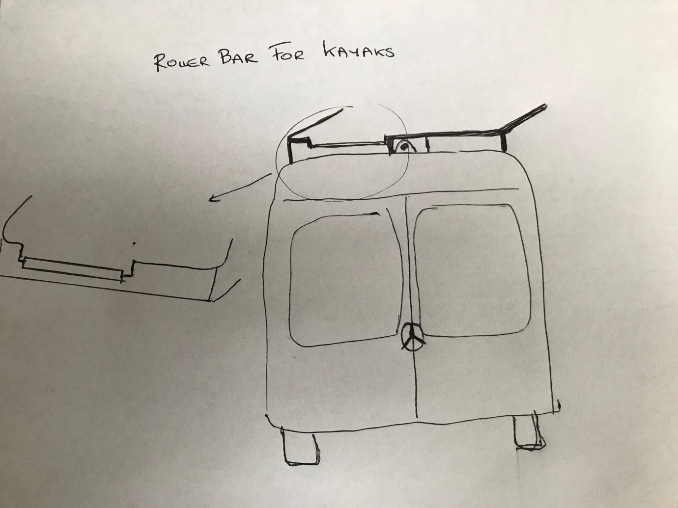

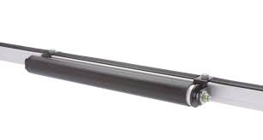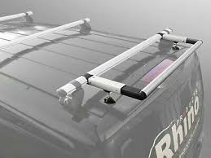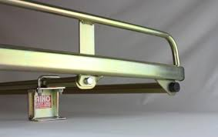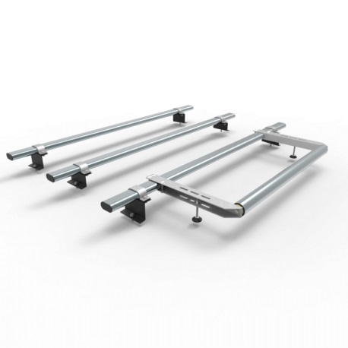

I would want some form of mounting for x2 14 foot long kayaks. Posts are ok but I think something that each kayak "sits in" is preferable, Like the picture below. If they can’t be fabricated must be able to attach existing products like one below. So may need to buy during roof rack build so any modification to roof floor re attachment can be done at this time

Current preferred kayak mounting device

https://www.amazon.co.uk/IKURAM-Carrier-Bilateral-Premier-Surfboard/dp/B087C1H1N4/ref=sr_1_1?dchild=1&keywords=IKURAM+Kayak%2FSurf%2FSki+Roof+Carrier+Rack+of+Bilateral+Premier+J-Style+Folding+4-in-1+for+Canoe%2C+SUP%2C+Kayaks%2C+Surfboard+and+Ski+Board+Rooftop+Mount+on+SUV%2C+Car+and+Truck&qid=1613479053&s=sports&sr=1-1

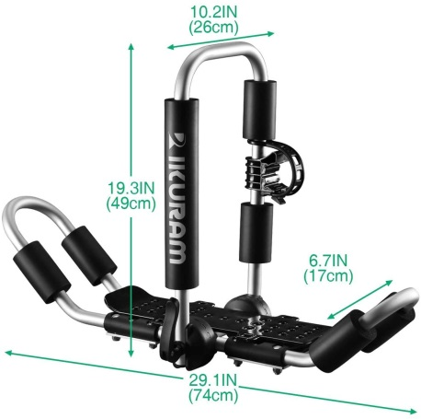 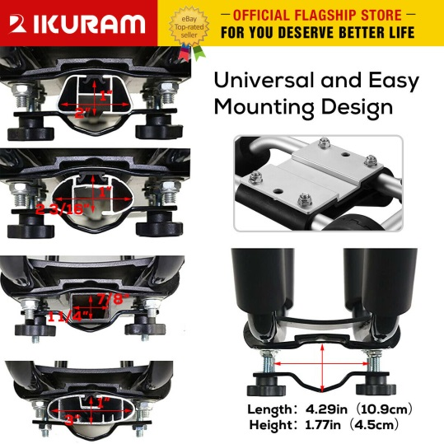

**Drill winch**

I would also want to have them housed so they can either be dropped or removable. Front of rack would need a mounting plate to attach a winch hook like the one shown below.

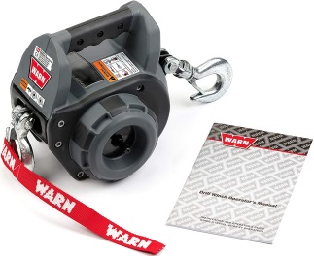

**Sun Deck canopy ( SEE PLANNED FLOOR PLAN AT END)**

I would also like in each corner and perhaps at the midsection, a box post so that upright posts can be slotted in to provide a canopy when needed.

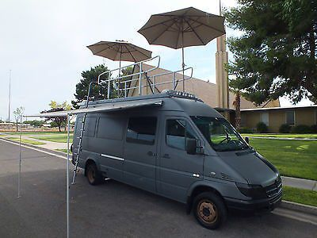 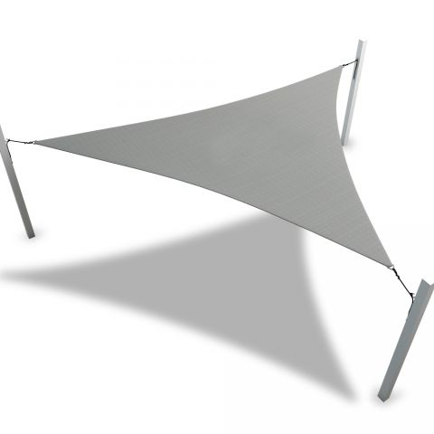 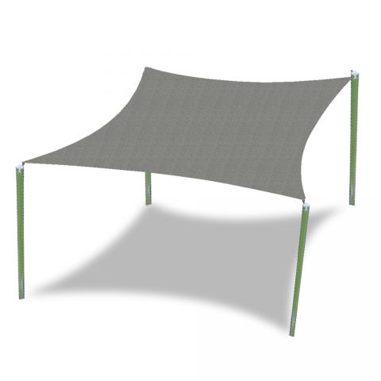

https://www.coversandall.co.uk/custom-sun-shade-sail-square.html

**Side extension bars for:-**

**Pull up bar**

**Hanging facility**

Box insert extension under the rack floor to the perimeter edge at side by ladder as Pull up bar and on awning side and at rear as a hanging facility

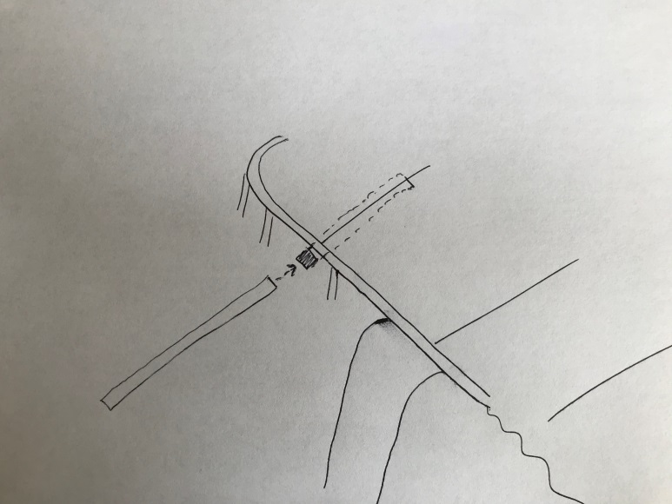

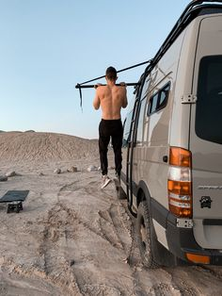 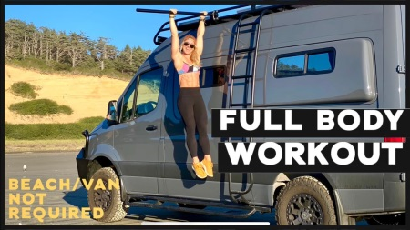

**CARGO STOWAGE SUPPORTS**

All round roof rack perimeter every 12 inches or so a hook or eyelet for cargo retention with rope etc

**FLOOR PLAN**

