**SEAN BURNS 2021 MERCEDES SPRINTER 319 AWD BUILD DRAFT SPECIFICATION V2**

**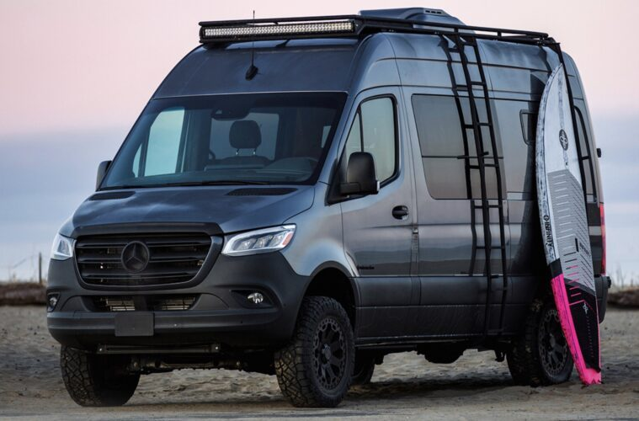**

**EXTERNAL**

The overall specification will be an “off-road”look

No decals at this time as unsure ?etched signage on inside rear door plates

**FRONT**

**Black Grill**

Replace chrome MB badge with black equivalent ( same with rear badge)

**Front nudge bars**

EU compliant

Not sure which one, these 2 look good will need to be in black powder coating not chrome

https://www.4x4works.co.uk/product/steeler-black-steel-a-bar-mercedes-benz-sprinter-series-3-2018-on-front-protection/



https://www.misutonida.com/en/1042-mercedes-sprinter-2018-

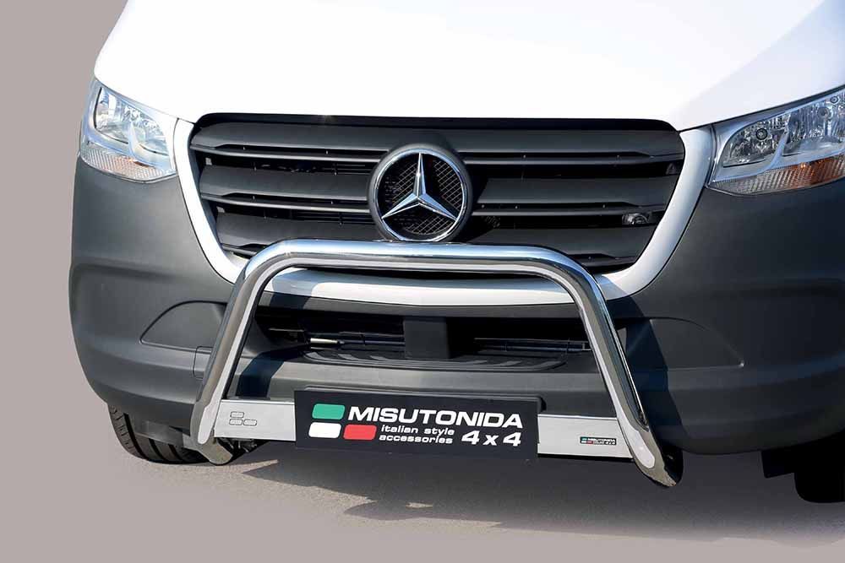

<https://tradevanaccessories.co.uk/QL/Front_Styling/Mercedes-Benz/Sprinter/2014-2018/>

<https://www.toys4vans.co.uk/mercedes-sprinter-bull-bars.html>

<https://vangadgets.co.uk/bull_bars.htm>

https://www.germansell.de/Bullbar/MERCEDES/Bullbar-with-crossbar-in-black-for-Mercedes-Benz-Sprinter-from-2018::3567.html?language=en&pk\_campaign=ger2212&gclid=EAIaIQobChMIluW-sbb77AIVCLTtCh1vLQ6SEAQYBCABEgLtk\_D\_BwE

**FRONT GRILL SPOT LIGHTS- need holders**

THIS IS THE IMAGE

<https://vancompass.com/collections/sprinter-4x4-2019/products/van-compass-mercedes-sprinter-2019-winch-mount-with-optional-tow-hooks?fbclid=IwAR2jKqDDzoyjDDU-kmi5CFwMtzn2kZQhYDEhUzntJ28WOq-huFdRevxaPXU>

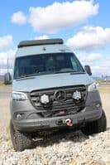

# <https://rhodesvans.co.uk/van-compass-mercedes-sprinter-2019-floating-light-mount-2019-3856-p.asp>

# IMAGE BELOW FROM https://adventurevanconversions.com/product/grill-lights-holder/ MAY BE ALTERNATRIVE BUT PREFER VANCOMPASS AS MOUNTING HIDDEN

# https://adventurevanconversions.com/wp-content/uploads/2020/10/sprinter-w907-2-1-2.jpg

# BONNET

# TERRAWAGEN 2019 ONWARD MERCEDES SPRINTER AERO HOOD SPOILER

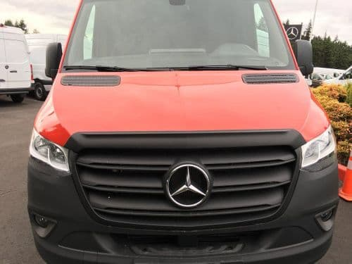

CONSIDER SNORKEL

**SIDE PROFILE**

SIDE WINDOW long narrow passenger/sliding door side

longer and slightly wider than one shown

**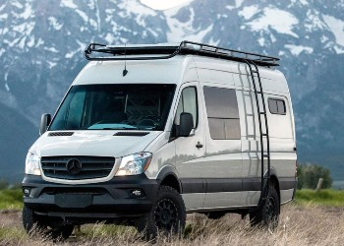**

<https://cdn.shopify.com/s/files/1/1908/9833/products/IMG_1798_300x300_crop_center.jpeg?v=1569039739>

# RECOVERY BOARDS FIXED TO SIDE OF VAN on driver/ladder side in the same position as long narrow window on the other side

# LIKE IMAGES BELOW

# https://adventurevanconversions.com/wp-content/uploads/2020/10/transit-3-1-2-350x350.jpg

# <https://adventurevanconversions.com/product/recovery-boards-holders-3/>

# https://adventurevanconversions.com/wp-content/uploads/2020/10/sprinter-w903-4-1-2.jpg

# https://adventurevanconversions.com/product/recovery-boards-holders/

# iF NOT THIS SYSTEM ? A BASE PLATE OF BLACK POWDER COATED ALUMINIUM PLATE WITH MOUNTING PINS ATTACHED LIKE STUFF USED FOR GARAGE LINING FIXED TO PANEL . nO BIGGER THAN MAXX TRAX SO COMPLETELY COVERED BY THEM

# https://www.maxtrax.com.au/product/maxtrax-mkii-black/

# WILL NEED MOUNTING PINS

# MaxTrax Mounting Pin Set

# https://www.maxtrax.com.au/mounting-pin

# OOPTIOM

# other oPTIONS FOR MOUNTING BUT NOT PREFERRED SEEN BELOW

# https://axiaalloys.com/product/pair-of-maxtrax-traction-board-mounts/

# \*\* these are good also have grill light holders <https://adventurevanconversions.com/product/recovery-boards-holders-3/>

# <https://www.expeditioncentre.com.au/recovery-tracks-holder-table>

# https://axiaalloys.com/product/pair-of-maxtrax-traction-board-mounts/

# https://www.instagram.com/p/CJl5x22BVxw/?igshid=y4y269mu6zjy

# https://expeditionessentials.com/products/recovery-board-quick-mount-rbqm

# <https://www.instagram.com/p/CJByA8hhJPV/?igshid=re7vsqrh1ovb>

# <https://nuthouseindustries.com/shop/rack-accessories/maxtrax-tred-pro-mounting-plates/>

# https://www.gtv-van.com/en/fold-down-system-for-lateral-attachment-of-recover.html

# <https://stoked-adventure.com/>

**FENDER**

Flare KIT

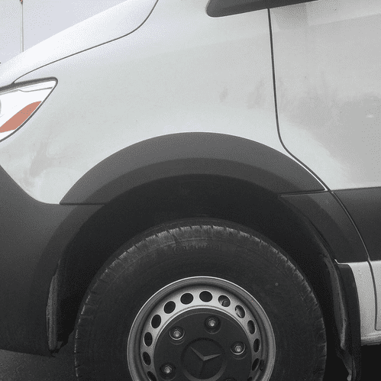

# TERRAWAGEN 2019 SPRINTER FENDER ARMOR KIT – need to check 2021 model?

# also fill in with raptor lower side panels

# bar protectors along bottom sill

# ?HEAVIER RAPTOR

# SEE BELOW

# C:\Users\The Van Traveller\Downloads\IMG_2727 (1).JPG

**WHEELS** –

**Alloys**

BLACK RHINO WARLORD MATTE BLACK W/MACHINE DARK TINT LIP

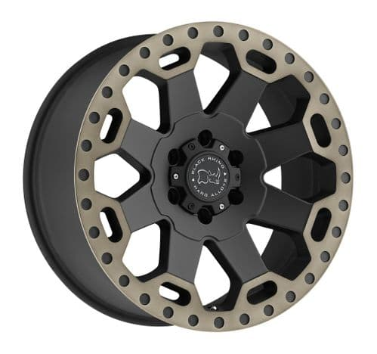

INCREASE WHEEL SIZE (re Previous build) NEEDS mudflap adjustment kit

Two seen links below

# TERRAWAGEN MONDO BIG TIRE KIT, SPRINTER (2019-2020)

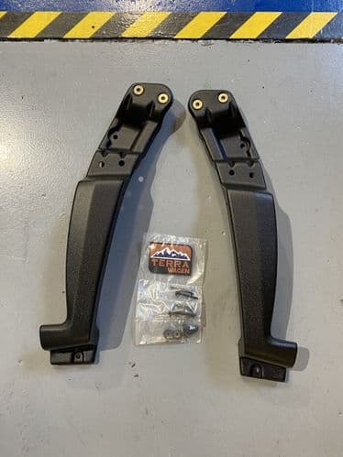

# OR <https://agileoffroad.com/product/agile-no-rub-fender-sprinter-2019/>

# <https://sprinterupgrades.com/products/front-wheel-well-enlarger-kit>

# AWNING

# ?MANUAL IS THERE Any electric MODELS available

# ROOF RACK

# C:\Users\The Van Traveller\Downloads\2020-11-24 12.09.09.jpg.jpeg

# Move solar panEl to middle 1/3 between 2 roof vents AND AS CLOSE TO OPPOSITE SIDE OF LADDER

# rack above level of vents

# slot in covers FOR ROOF VENTS in fenestrated aluminium

# C:\Users\The Van Traveller\Pictures\VAN THINGS TO CONSIDER (1).png

# front attachment for w ARN 750 DRILL winch

# https://images-na.ssl-images-amazon.com/images/I/81XRE-OlqHL._AC_SL1500_.jpg

# rear perimeter bar drops down in the middle 1/3 with roller

# posts 2 kayaks NEED TO BE DETACHABLE OR FOLD DOWN WHEN NOT IN USE

# bACK THIRD OF ROOF RACK AS A VIEWING PLATFORM WITH HINGED FOLD UP BACK REST

# *MAY BE WORTH MEETING WITH MANUFACTURER TO DISCUSS FURTHER*

# SIDE LADDER AS PART OF ROOF RACK

# WHEEL CARRIER FITTED

# This company look good/ same as recovery board mounts

# https://adventurevanconversions.com/product/spare-wheel-carrier-3/

# https://adventurevanconversions.com/wp-content/uploads/2020/11/sprinter-W903-14-1-2-350x350.jpg

# REAR GARAGE

# ALL ALUMINIUM PLATE

# <https://www.instagram.com/p/CIqes2sB68M/?igshid=1t7s4fcsblhv9>

# tAMBOUR DOOR ACCESS

# FLOOR TRACKS WITH RING BOLTS FOR SECURING ITEMS

# heated

# lighting as above

# ?rear step

# ATTACHMENT FOR 2 BIKE FRONT WHEELS TO REAR DOOR ONE SIDE

# OTHER SIDE ONE OF THESE AND SHOWER ATTACHMENT

# C:\Users\The Van Traveller\Downloads\vodafone UK.jpeg

BULK HEAD racking for skis

Loads of garage type hooks that will do the job eg

https://www.amazon.co.uk/gp/slredirect/picassoRedirect.html/ref=pa\_sp\_btf\_sports\_sr\_pg1\_1?ie=UTF8&adId=A0160607321HSW47LX182&url=%2FStorage-Hangers-Utility-Anti-Slip-Coating%2Fdp%2FB08BKL1HF6%2Fref%3Dsr\_1\_22\_sspa%3F\_encoding%3DUTF8%26c%3Dts%26dchild%3D1%26keywords%3DIndoor%2BSki%2BStorage%26qid%3D1611327136%26s%3Dsports%26sr%3D1-22-spons%26ts\_id%3D3076788031%26psc%3D1&qualifier=1611327136&id=1922109197021731&widgetName=sp\_btf

**OFF GRID SET UP FOR POWER**

**NEED TO MAX OUT HERE TO BE DISCUSSED FURTHER**

**INTERNAL**

**REAR BULK HEAD**

Removable panel have a lip to the outside garage side with internal clips. Take wide to avoid back when sat up

**SEATS**

**SOME LIKE THIS LINK BUT DARK BLUE TARTAN**

<https://www.instagram.com/p/CJV2C_OMlj0/?igshid=19fpsrk4ahzhp>

?IS IT POSSIBLE TO USE THIS COMPANY

**TABLE**

Something like this AS IT INCORPORATES PAASENGER SWIVEL SEAT. NEED TO ORDER AS PER CLOUR SCHEME TO BE DECIDED UPON WEEK BEGINNING 15/2 WHEN THE WIFE WILL VISIT PREMISES

**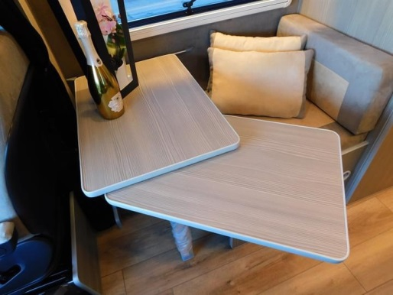**

<https://www.evomotiondesign.co.uk/product/rotating-table-leg-twin-worktops-tops-mito-table-rail/>

LOOK AT THIS WEBSITE FOR IDEAS

**WET ROOM**  Want hot air vent from TRUMA heating system into wetroom so can act as drying room when not in use. ? extraction roof vent

**THINGS FOR SEAN TO CONSIDER**

GENERATOR

COMPRESSOR

SECURITY – kill switch, area for concealed safe

https://www.ebay.co.uk/itm/Mercedes-Benz-ALL-MODELS-DUMMY-FAKE-OBD2-PORT-POWERED-anti-theft-security-Guard/323674543781?epid=17028885892&hash=item4b5c8196a5:g:YWIAAOSwl1RcU2Y-

Tracking in garage ?on roof internally

MOUNTS FOR 2 BIKES FRONT FORKS

Ipad mounts <https://www.scosche.com/mounts-product-finder>

WARN DRILL WINCH

REAR DOOR SHOWER HOLDER

?UNDERBODY PROTECTION

WET ROOM STORAGE

PORTABLE WASHING MACHINE <https://shop.luvleygifts.com/>

<https://portable-washer.com/products/portable-washing-machine>

CCTV